PHYS1006 – Lab #4: Springs and Masses
____________________________________________________________
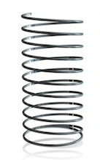

/38 = %

GROUP MEMBERS’ NAMES
- _____________________________
- _____________________________
- _____________________________
- _____________________________

Evaluation / Due Date
- This lab is worth 5% of your final grade. It is due before 2 pm on Wednesday March 24th.
- Only students participating in the lab will be eligible to receive marks.
- Each group member will receive the same grade.

Purpose
To investigate how a mass at the end of a spring moves by studying the properties of the spring.

Background
When a solid is squeezed or stretched, the interactions between the molecules of the solid are key to determining what the resultant shape will look like. Elastic materials return to their original shape after being deformed by some external force. The intermolecular forces pull the molecules back to their original position, which makes the solid return to its original shape when the force is removed. There is a limit to how much external force a material can withstand and return to its original shape. The elastic limit is the maximum force per unit area that a material can be subjected to before permanently deforming it. At this limit, the intermolecular forces are overcome and the molecules slide past one another.

When a coil spring is stretched by a weight, it is deformed but will return to its original shape and length. If stretched too far, the elastic limit may be exceeded and the spring will be permanently stretched out of shape. Before this point, a spring will stretch by a length that is proportional to the weight pulling on it. Hooke’s Law is relationship that is directly proportional to the stretch, or change in length, d, (in meters) and the applied force, F, (in Newtons). k is a positive proportionality constant with units of Newtons/meter that is unique for each spring (spring constant):
$$F=kd$$
$$∴k= \frac{F}{d}$$

When a mass is attached to the end of a spring and it is allowed to bounce, the period, T, (in seconds) refers to the length of time it takes the mass to bounce up and down. The period is determined by the spring constant, k, and the size of the mass, m (in kilograms):
$$T=2π\sqrt{\frac{m}{k}}$$
Materials
The following materials are needed to complete this lab:
- Timer
- Tape measure
- Spring and support clamp
- Various masses
- Calculator and ruler

Procedure
- Attach the spring to the support and measure the distance from the support to the bottom end of the spring. This is the resting length, d_{rest}. Record this in Table 1.
- Attach a small mass (about 200 g) to the spring and measure the new distance, d, from the support to the end of the spring. Record this mass in kilograms and distance in meters in Table 1.
- Calculate the force, F, of gravity exerted on the mass. Use gravity = 9.8 m/s².
$$F=mg$$
- Calculate the distance the spring stretched with the new mass, d_{stretch}.
$$d_{stretch}=d- d_{rest}$$
- Start the mass bouncing so it moves about 1 cm up and down. Time how long it takes to make 20 oscillations. Record this time, t₁ in seconds in Table 1.
- Repeat step 5 to ensure a good measurement. Record this time as t₂.
- Calculate the average time. Record this time as t_{avg} in Table 1.
- Calculate the length of time for one oscillation. This is the period, T. Record in Table 1.
- Repeat steps 2 to 8 a total of five times by adding additional small masses (e.g. total mass of 300g, 400g, 500g, 600g). Do not exceed the limits of the spring (700 g).
- For F, d_{stretch}, t_{avg}, and T, show a sample calculation in the space provided (pick one mass from Table 1 and use those values).

Results (10 marks)

Table 1 – Oscillations of a spring. Columns marked with a * are CALCULATED.
m (kg) | F (N) * | d (m) | d_{stretch} (m) * | t₁ (s) | t₂ (s) | t_{avg} (s) * | T (s) *
0.00 | 0.00 | d_{rest} = 0.150 | 0.00 | - | - | - | -
0.200 |  | 0.163 |  | 9.79 | 10.37
0.250 |  | 0.181 |  | 11.94 | 11.96
0.300 |  | 0.202 |  | 13.12 | 13.16
0.400 |  | 0.237 |  | 15.22 | 15.06
0.600 |  | 0.308 |  | 18.50 | 18.55

Sample Calculations: (4 marks)
Show a sample calculation in the spaces provided (pick one mass from table 1 and use those values). Include formulas, substitution, and final answer with appropriate units

FORCE:

STRETCH DISTANCE:

AVERAGE TIME:

PERIOD:

Analysis and Discussion Questions
- Graphs and Analysis: (12 marks)
  - On graph #1 below, plot F versus dstretch with dstretch as the independent variable (x-axis). The graph may not go through the origin (0, 0). It should be a straight line.

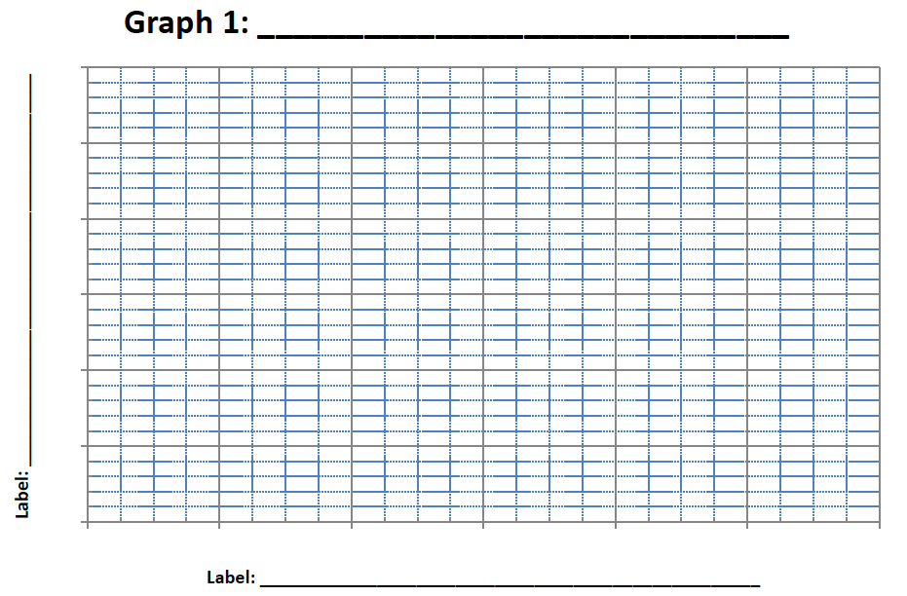

  - From the graph, determine the spring constant, k, from the slope of the graph. Use the graph (slope) or the data table.
$$slope= \frac{rise}{run}= \frac{y_{2}- y_{1}}{x_{2}- x_{1}}= \frac{F}{d}=k$$

  - On graph #2 below, plot T versus m with m as the independent variable (x-axis). The graph may not go through the origin (0, 0). It should be a curved line.

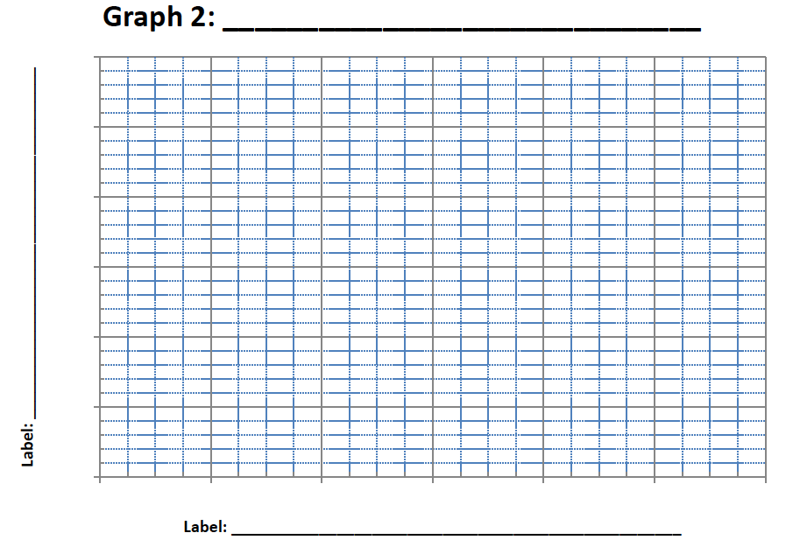

  - Choose one mass from the table and verify the period using the calculated spring constant.
$$T=2π\sqrt{\frac{m}{k}}$$

- Discussion: (12 marks)
  - Does the graph of F vs. dstretch show that there is a spring constant for the spring? Explain.

  - Does the spring stretch exactly twice as far when twice as much force is applied? Explain.

  - What does the graph of T vs. m look like? Explain why.

  - Should the period increase or decrease with an increase in mass? Why?

  - Does the period of oscillation as calculated from the equation agree with experimental results? Explain using your data.

  - If the mass of a car is known (from the owner’s manual), how could the spring constant of the car’s springs be determined? Describe.

